1. **PROTOTYPE TYPE:** Half Wave Rectifier
2. **Simulation Results:**
3. Detailed description of the simulation results :-

Components required –

|  |  |  |
| --- | --- | --- |
| Materials Required | Specifications | Qty |
| Bread board |  | 1 |
| CRO | 20/30Mhz | 1 |
| Diodes | IN4007 | 1 |
| Resistors | 1K | 1 |
| Transformer | 9-0-9 | 1 |
| Connecting wires |  | Lumsum |
| Probe |  | 2 |

Connect diode on breadboard through a Transformer. Transformer has three wires 9-0-9 where 9&9 are positive and 0 is ground since half wave rectifier we are using one diode we need only one positive terminal and it is connected to anode part of the diode and 0 is connected to ground. Connect resistor 1k on breadboard it is used as load resistor and connected from cathode terminal to the ground. Connect CRO of input output channel using probes.

1. Include screenshots or diagrams

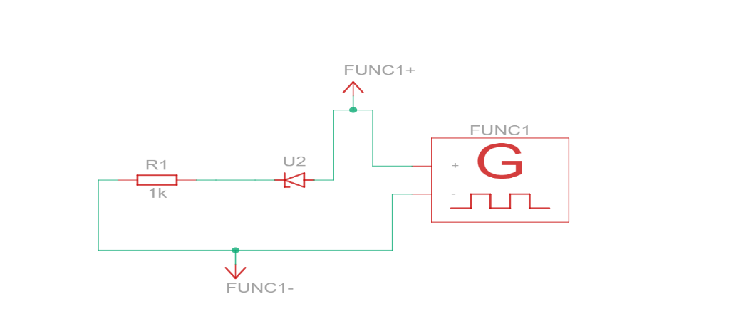

**Circuit diagram**

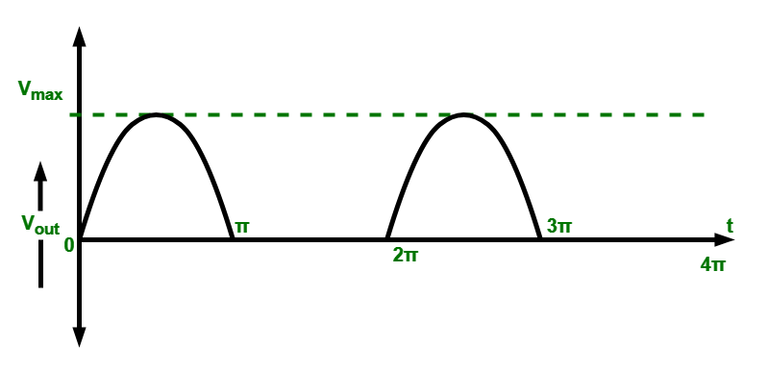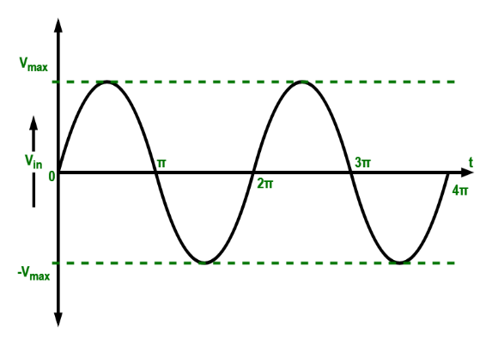

**Full Wave Half Wave**

C. Illustrate key aspects of the simulation

**Such as input/output wave forms**:- CRO is having two channels channel one used for input signal and channel two for output signal after connection the result waveform will be displayed as full waveform then it is converted into halfwave because diode will conduct only in 1 direction output of positive terminal of the probe will be connected cathode part of the diode & negative connected to ground we will be using channel to as output.

Here output will be rectified one during positive half cycle diode conducts during negative half cycle diode will be off. Output will be only for positive half cycle.

1. **Hardware Results:**
2. present hardware implementation of the prototype on bread-board.

* Include measurements, observations:

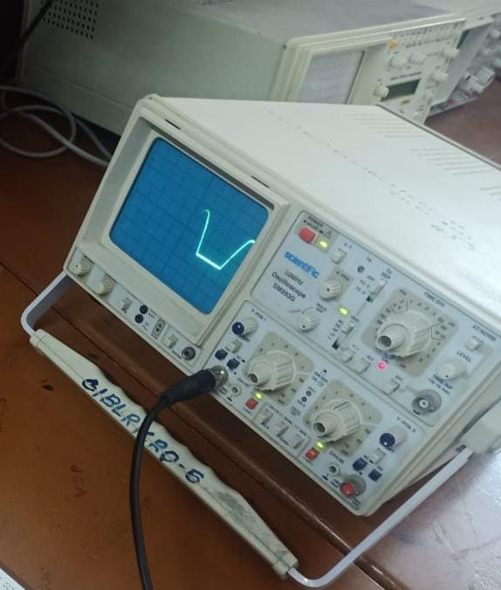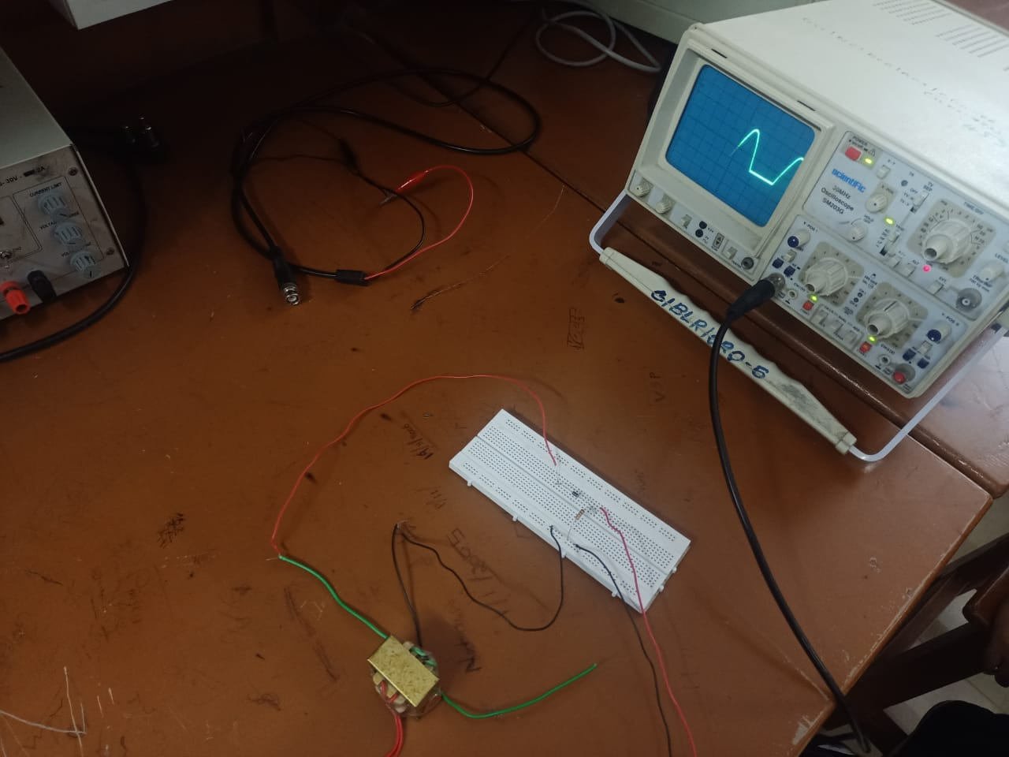

1. **Comparison of Simulation and Hardware Results**

**Simulation results:** Use software like Multisim or MATLAB

Here are some of observations from a simulation of half wave rectifier

* Waveform shape
* Peak voltage
* DC Component
* Load effects

**Hardware results:** Hardware implementations involve constructing the circuit on a breadboard or PCB. Hardware implementations reveal additional complexities and imperfections.

Some possible reasons for variations are:-

1. Component tolerances and Non-Idealities
2. Power supply variations
3. Thermal effects
4. Measurement inaccuracies
5. Imperfect modelling
6. Load effects
7. Circuit layout
8. **Design Finalization :**

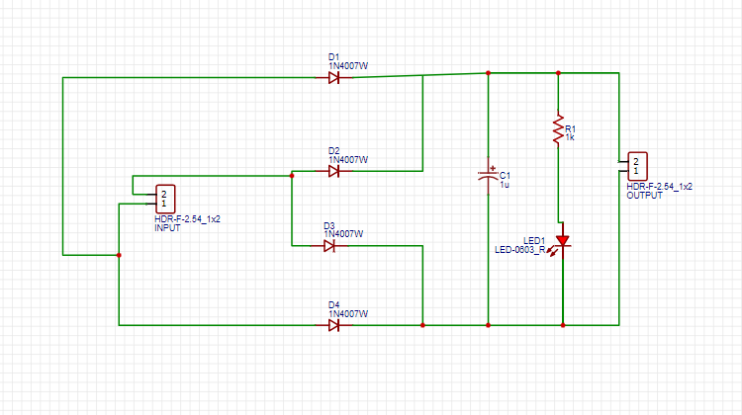

1. **Circuit building on Easy EDA tools**
2. Outline the process of translating the finalized design into a circuit layout
3. Provide step-by-step instructions, screenshots

* In Easy EDA Software draw the circuit accordingly

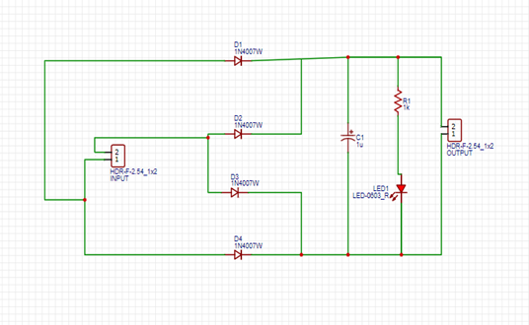

* Then save the circuit and convert schematic to PCB
* Then arrange the components and auto route so that it will arrange accordingly

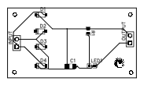

* Change PCB to any 2D and 3D model view

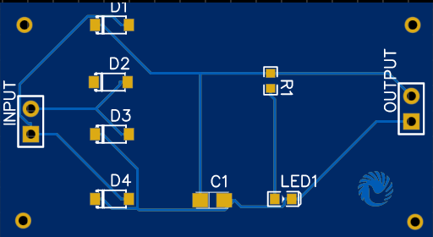

1. **PCB Designing on Easy EDA Tools:**
2. Describe the process of designing the PCB layout based on the circuit layout
3. After designing the circuit convert that schematic to PCB
4. Then place the components and click on route and press auto route so that the components will be arranged accordingly
5. Then layout can be changed to 2D and 3d model to view the final design
6. Explain how to place components, route traces, and optimize the PCB layout for manufacturability and performance.

* Components can be placed with the minimal space inside the layout after that place all the components
* After placing click the track and connect the components
* Holes can be inserted at the corners
* Auto route for better PCB Design

1. **Verification of the final design**

a. Detail the steps taken to verify the final PCB design